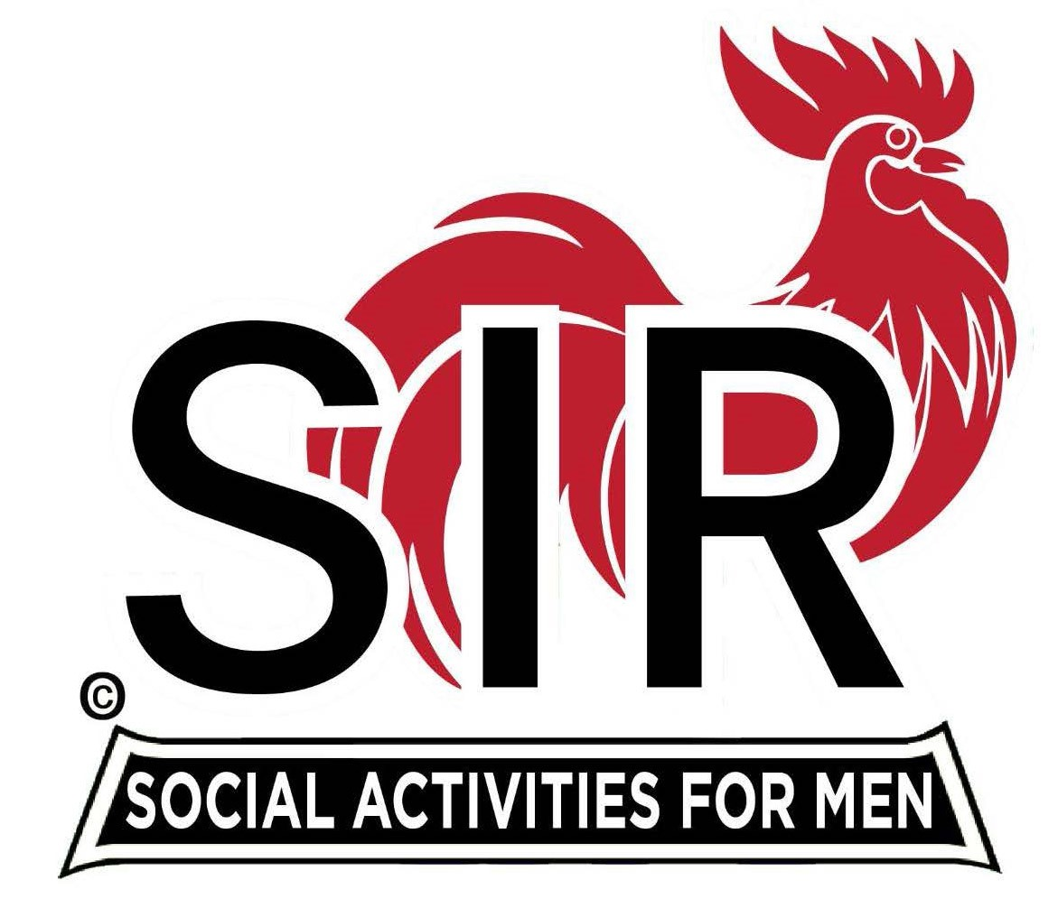**Las Trampas Branch 116**

**BEC Meeting Agenda**

**September 16, 2024, 9:15 AM at Boundary Oak**

***The Mission of SIR is to enhance the lives of our members through fun activities, events and luncheons while making friends for life.***

**9:15 am Call to order; Secretary, Paul Ramacciotti – Confirm quorum and**

**Approval of August 19, 2024 BEC meeting minutes**

**9:20 am Standing Reports**

* **Treasurer Report – Charlie Guthrie**
* **Report**
* **Dues**

* **Luncheon Report – Dennis Snarr**
* **September 18 Boundary Estimated Count**
* **Big SiR – Alan Pope**
* **Branch Meeting – Branch 116, 146, 8 (negotiations with Bounday Oak)**
* **Annual SIRS Meeting**
* **Free lunch for past Big SIRS**

* **Membership – Phil Goff**
  + **New member; Erik Linak, Sponsor Jeff Johnson**

**4. RAMP Department Head Reports**

* **Recruitment**
* **Activity Coordinator – Mike Ward (Branch 146 Glen Breslin)**
* **Member Relations -**
* **Publicity – Robin Lemmo**

**9:40 am Little SIR Updates – Paul Russell**

* **Speaker Info – Ed Holloway, Blackhawk Museum Docent**
* **Birthday Boys – September**

**9:50 am Updates & New Business**

* **Holiday Party**

**10:15 am Adjourn: Lunch Preparation**